**IOT Practical 7**



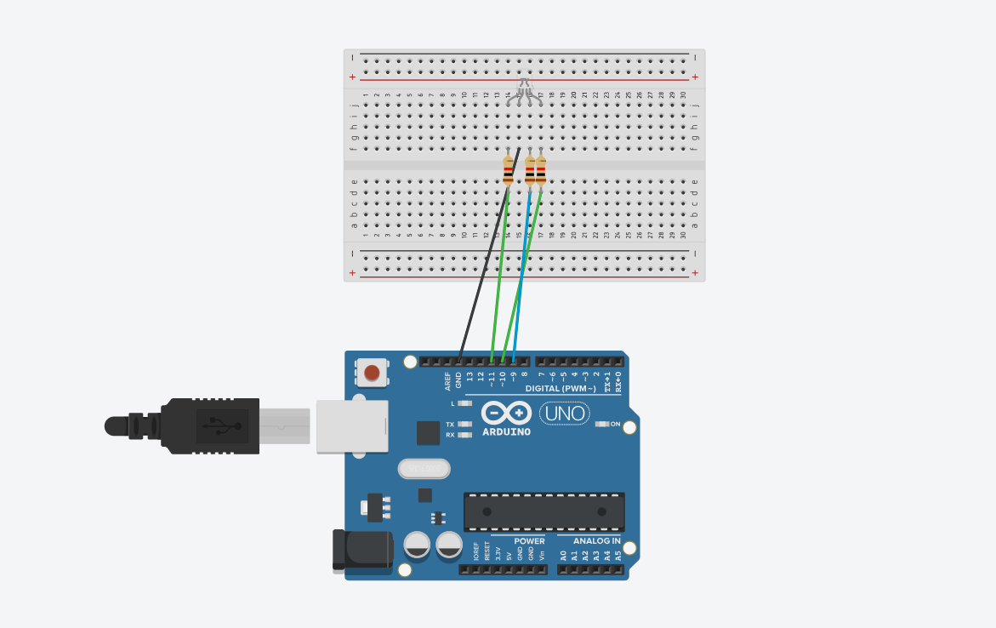

/*

/*

Adafruit Arduino - Lesson 3. RGB LED

*/

int redPin = 11;

int greenPin = 10;

int bluePin = 9;

//uncomment this line if using a Common Anode LED

//#define COMMON_ANODE

void setup()

{

pinMode(redPin, OUTPUT);

pinMode(greenPin, OUTPUT);

pinMode(bluePin, OUTPUT);

}

void loop()

{

setColor(255, 0, 0); // red

delay(1000);

setColor(0, 255, 0); // green

delay(1000);

setColor(0, 0, 255); // blue

delay(1000);

setColor(255, 255, 0); // yellow

delay(1000);

setColor(80, 0, 80); // purple

delay(1000);

setColor(0, 255, 255); // aqua

delay(1000);

}

void setColor(int red, int green, int blue)

{

#ifdef COMMON_ANODE

red = 255 - red;

green = 255 - green;

blue = 255 - blue;

#endif

analogWrite(redPin, red);

analogWrite(greenPin, green);

analogWrite(bluePin, blue);

}